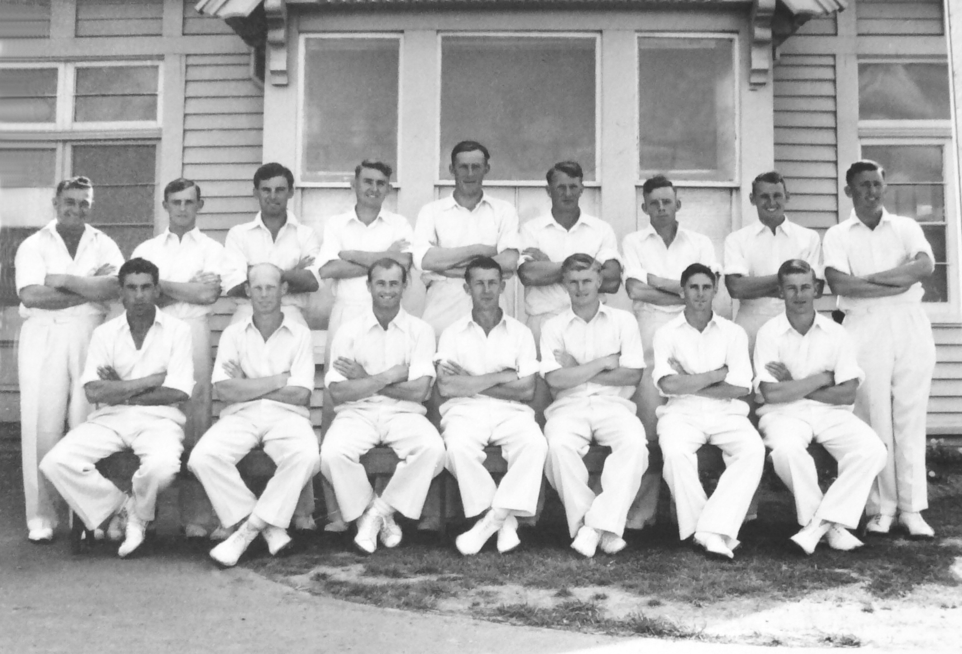

**Canterbury Representative Team 1956/57**

**Back Row:** GN Gearry, I McK Sinclair, BMJ Dineen, DJ Reid, AR MacGibbon, KJ McNichol, JW Kiddey,

AG Duckmanton, ME Chapple

**Front Row:** SCGuillen, MB Poore, PGZ Harris, RT Dowker (captain), JW D’Arcy, BA Haworth, DL Gallop